

MANAV RACHNA UNIVERSITY, FARIDABAD

Department of Computer Science & Technology

Course: B.Tech(CSE) Semester:IV Subject: Programming for Problem Solving using Python(CSW208B) Session: 2020-21

*Lab -2: Programming constructs in python -hands-on practice*

*Learning Outcome* : *Student will be able to understand the basics of Python programming language*

*Blooms Taxonomy Level: BT2*, *BT3*

**Name kajiman lawati cse 4c 1141**

1. [Check whether a number is even or odd](https://www.programiz.com/python-programming/examples/prime-number)
2. [Check whether an entered year is leap year or not.](https://www.programiz.com/python-programming/examples/prime-number)
3. Write a program to check whether a character is vowel or consonants.
4. Write a program to find the smallest of two numbers.
5. [Find the Factorial of a Number](https://www.programiz.com/python-programming/examples/factorial)
6. Write a program to print this patterns

*

* + *
  + * *
  + * * *

1. Write a program to print this series

1 1 2 3 5 8 13

1. [Check whether a number is prime or not](https://www.programiz.com/python-programming/examples/prime-number)9. [Make a Simple Calculator.](https://www.programiz.com/python-programming/examples/calculator)

RESULT:

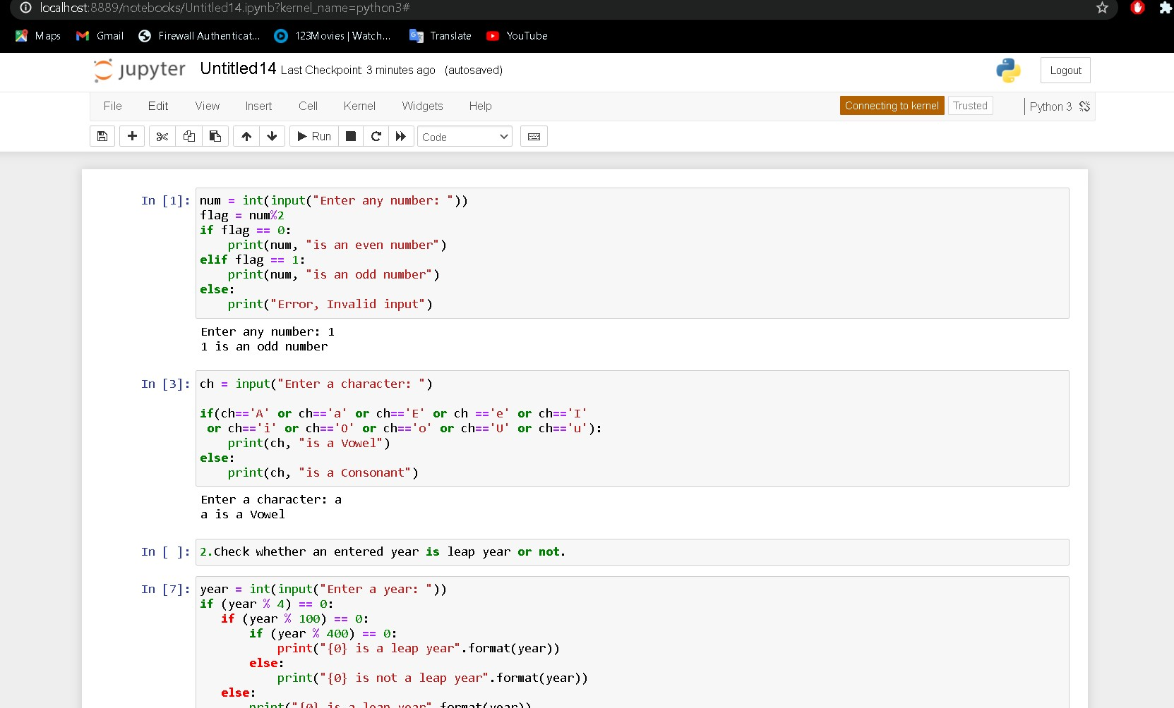

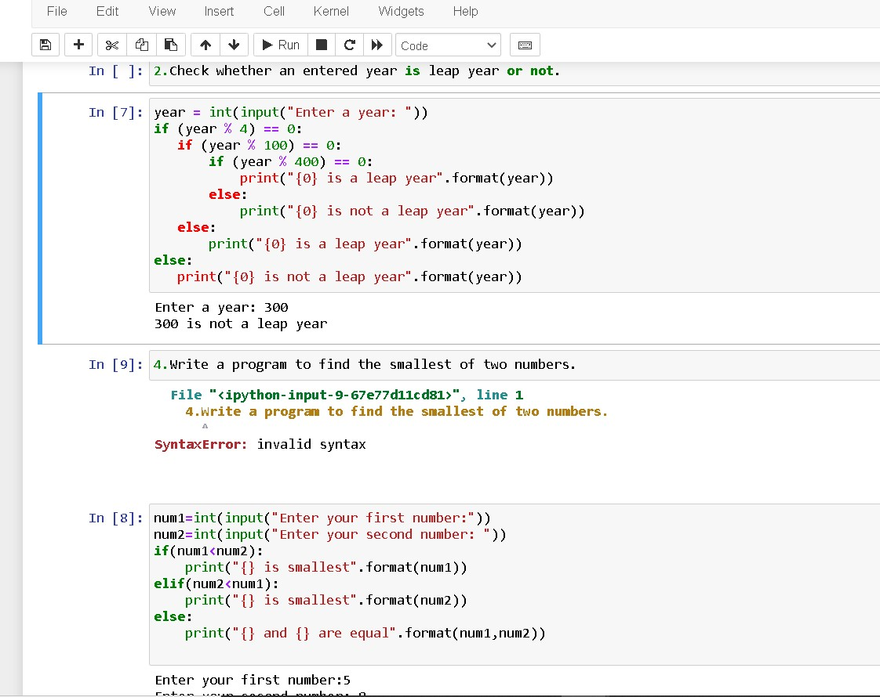

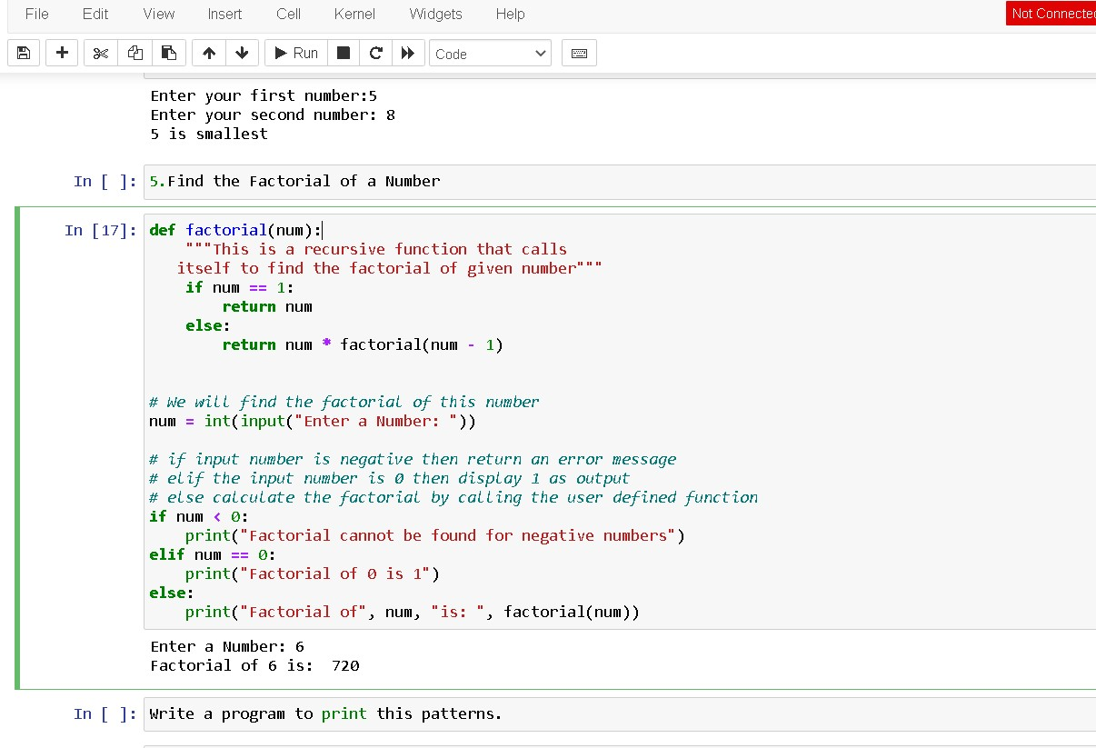

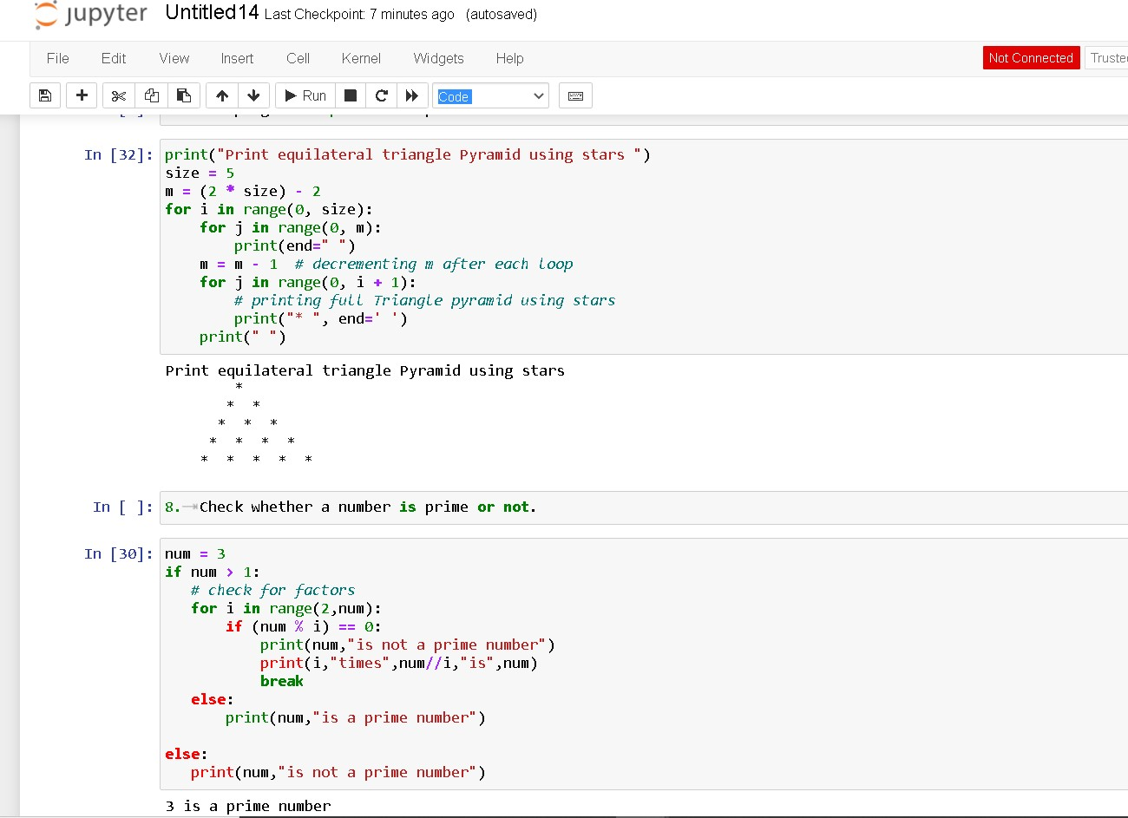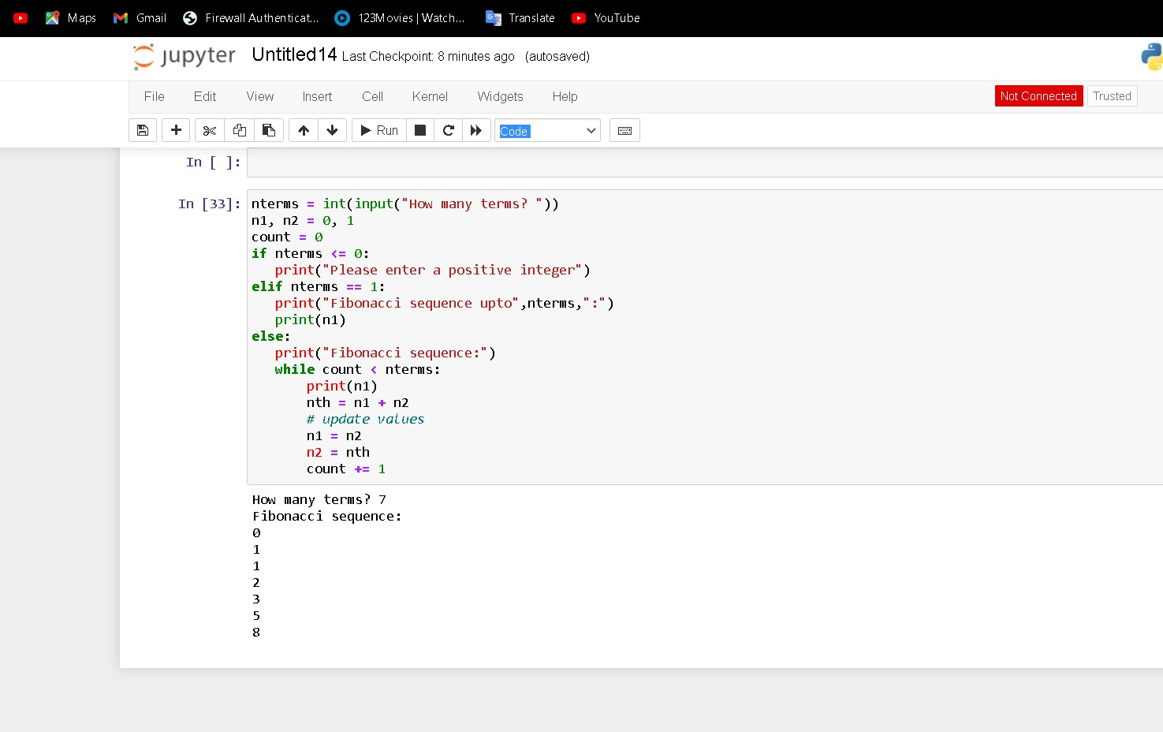

CALCULATOR

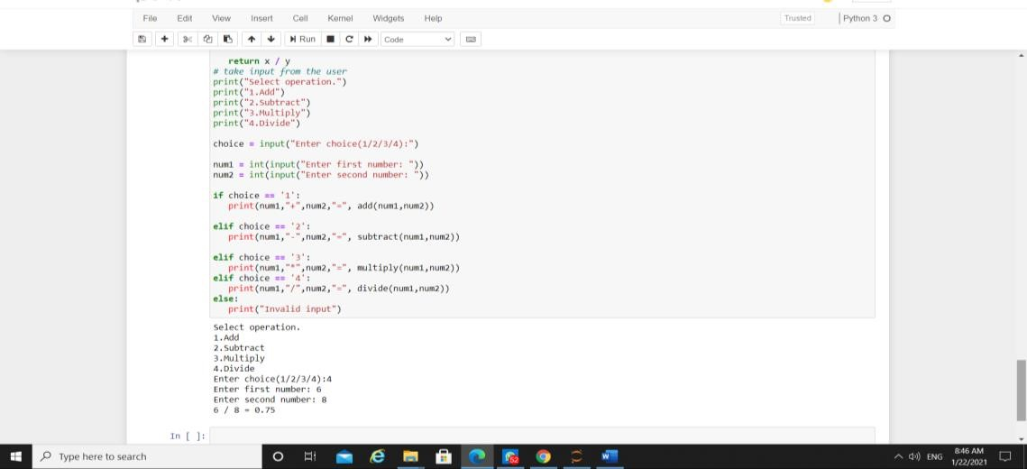

# **Lab-3:** Strings and list- hands-on practice

1. WAP to demonstrate while loop with else statement

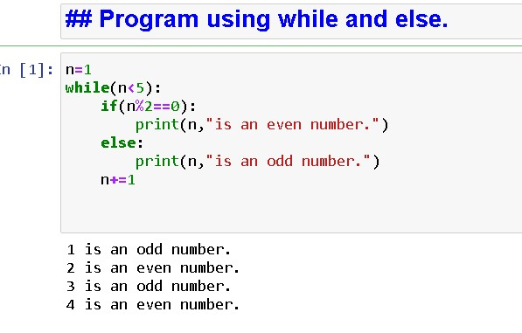

2.Print 1st 5 even numbers (use break statement).

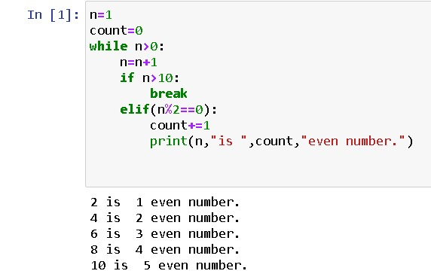

1. Print 1st 4 even numbers (use continue statement

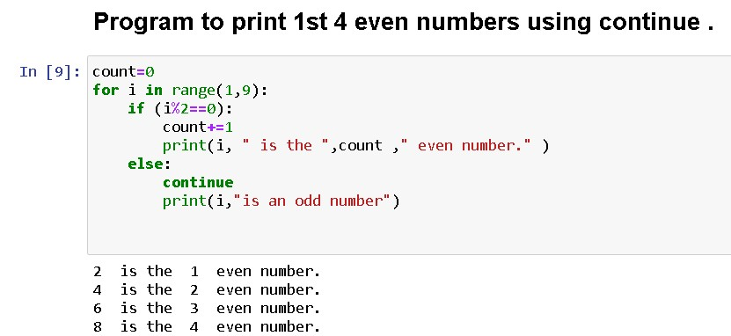

1. WAP to demonstrate Pass statements.

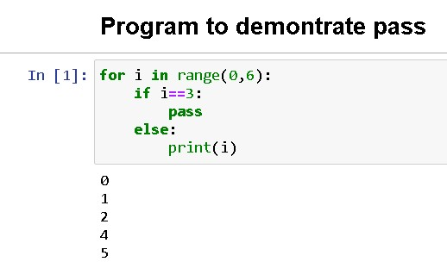

5.Write a Python program to calculate the length of a string.

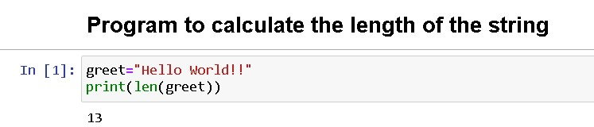

6.Write a Python program to count the number of characters (character frequency) in a string.

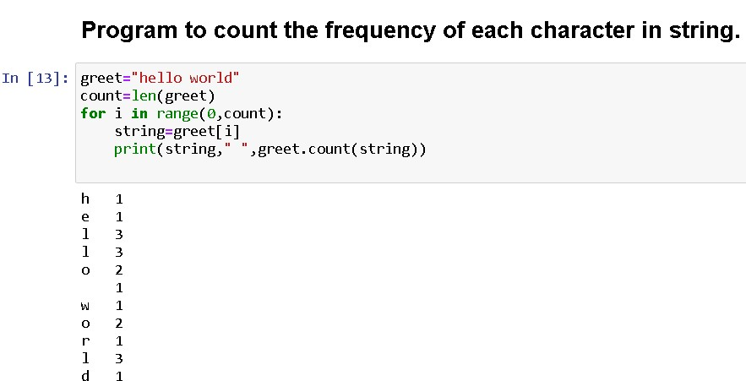

7.Write a Python program to get a string made of the first 2 and the last 2 chars from a given a string. If the string length is less than 2, return instead of the empty string.

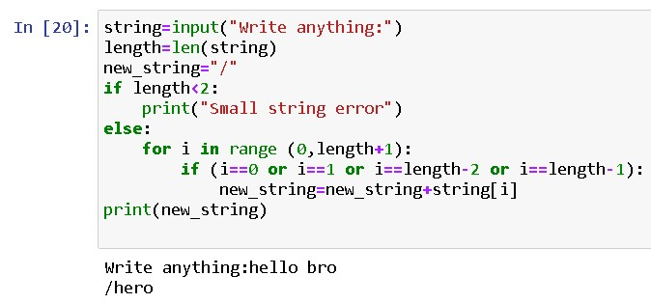

1. Write a Python program to get a string from a given string where all occurrences of its first char have been changed to '$', except the first char itself.

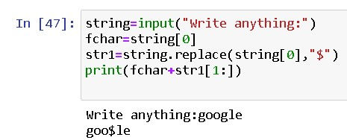

8.Write a Python program to get a single string from two given strings, separated by a space and swap the first two characters of each string.

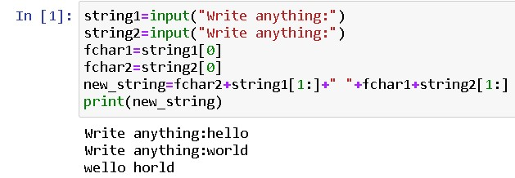

9.Write a Python program to add 'ing' at the end of a given string (length should be at least 3). If the given string already ends with 'ing' then add 'ly' instead. If the string length of the given string is less than 3, leave it unchanged.

